[**How to Deploy Springboot Microservices into AKS cluster using Helm and Azure Pipelines | Deploy Docker Containers into AKS cluster using Azure Release Pipelines | Deploy Microservices into AKS cluster using Helm and Azure Pipelines**](https://www.coachdevops.com/2023/04/how-to-deploy-springboot-microservices.html)

We are going to learn how to deploy Spring boot Microservices Docker container into Azure Kubernetes Cluster (AKS) using Helm and Azure pipelines.

**Sample spring boot App Code:**

I have created a sample [Spring boot App](https://github.com/akannan1087/docker-spring-boot/)setup in GitHub. Code - https://github.com/akannan1087/docker-spring-boot/

[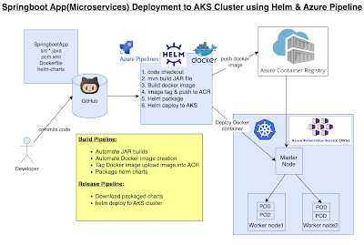](https://blogger.googleusercontent.com/img/b/R29vZ2xl/AVvXsEi7qi2ftz__MrIvUe19_BT73TiGuTJ_WcLk52gNiIis4IKTG-mLqFZpCSvCzTY6YWHRfVuLGdCqQVUdOSA_N8hlFaTlysdVQRR62mWTwKjMsPj0D-WYWARN_J8iD6yisLmlHeg3zVxbJ9R4pmdV8le3lVsARK-f5Y4GZZCz6HY1tJxz4qIqCrq2wLYS/s1864/Screenshot%202023-05-04%20at%208.19.18%20AM.png)

**Watch steps in YouTube channel:**

**What is Helm?**

Helm is a package manager for Kubernetes. **Helm** is the K8s equivalent of yum or apt. It accomplishes the same goals as Linux system package managers like APT or YUM: managing the installation of applications and dependencies behind the scenes and hiding the complexity from the user.

**Helm Charts**

[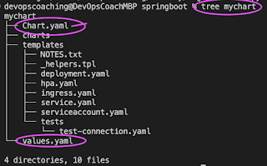](https://blogger.googleusercontent.com/img/b/R29vZ2xl/AVvXsEjxL-IDpNrKtxPWEZ_JKJyKeWWVp3iv3ZPs84g10C0oZJ0q0SqcDEdKSjpUWpOxq4ccdgLUcfkBTWGA-qYejQqBHLkDGxJMS-U1ijbALylzOU3mbu3cC-_ZUB7SwnrXG0z59zXRpBx8rDK7zcIq-Ds_AMpAtD40zOPg0bUP11eR9DczpTxF-ZHi0ATG/s583/Screenshot%202023-04-29%20at%2011.08.58%20PM.png)

Helm uses a packaging format called Charts. A Helm Chart is a collection of files that describe a set of Kubernetes resources. Helm Charts helps **you** define, install, and upgrade even the most complex Kubernetes application. Charts are easy to create, version, share, and publish.

**Implementation steps:**

1. Create a resource group, AKS cluster and Azure container registry
2. Provide pull access for AKS to pull image from ACR
3. Create a namespace for helm deployment
4. Create a helm chart for spring boot app
5. Create a build pipeline to automate docker image
6. Customize pipeline with helm package tasks
7. Create a release pipeline
8. Customize pipeline with helm upgrade tasks
9. Run the pipeline to deploy springboot app into AKS
10. Verify deployments in the namespace in AKS
11. Use kubectl port forward to access app locally
12. Access the app in the browser

**Pre-requisites:**

* [Azure CLI](https://www.coachdevops.com/search/label/Azure%20CLI) is installed on your local machine.
* [Helm installed](https://www.coachdevops.com/2021/03/install-helm-3-linux-setup-helm-3-on.html)
* kubectl installed.
* Azure subscription, click [here](https://azure.microsoft.com/en-us/free/) if you don't have one.
* AKS cluster needs to be up and running. You can create an AKS cluster, and ACR Repo using the [shell script](https://www.coachdevops.com/2023/04/shell-script-for-creating-aks-cluster_25.html) provided in my website.
* Azure DevOps project dashboard in <https://dev.azure.com/>
* [Dockerfile](https://github.com/akannan1087/docker-spring-boot/) created along with the application source code for the springboot App.
* Make sure [AKS has pull access from ACR](https://www.coachdevops.com/2021/10/configure-acr-integration-for-existing.html)

**Create a Helm chart using the helm**

Go to the root of the repo where you have the source code for your springboot application. Create a helm chart by executing the below command:

helm create mychart

[](https://blogger.googleusercontent.com/img/b/R29vZ2xl/AVvXsEhkbCXA0i2Sfocvc222HU252xDmS1-TCFW5nROys8tlZWwfwBO_9BFCC78xqC8iaJb3ZsV5rKYWqkrmO_80WfQdFUKjyBWZn_HdXfqM2NrA6amTMuRXxbN7z1jZ3y4yYcavbpxxec8L69i_Lj_pYwJhmRZjySGPDqvMPbaFqeEDup8QBntSmk_wGh3a/s654/Screenshot%202023-04-29%20at%2011.06.51%20PM.png)

tree mychart

Execute the above command to see the files created.

[](https://blogger.googleusercontent.com/img/b/R29vZ2xl/AVvXsEjxL-IDpNrKtxPWEZ_JKJyKeWWVp3iv3ZPs84g10C0oZJ0q0SqcDEdKSjpUWpOxq4ccdgLUcfkBTWGA-qYejQqBHLkDGxJMS-U1ijbALylzOU3mbu3cC-_ZUB7SwnrXG0z59zXRpBx8rDK7zcIq-Ds_AMpAtD40zOPg0bUP11eR9DczpTxF-ZHi0ATG/s583/Screenshot%202023-04-29%20at%2011.08.58%20PM.png)

Add Docker image details to download from ACR before deploying to AKS cluster

open mychart/values.yaml

[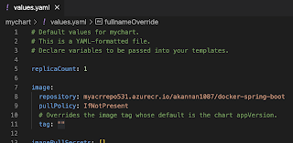](https://blogger.googleusercontent.com/img/b/R29vZ2xl/AVvXsEiXGRzwBveV8p7SGSm4GkO_PLU0h9aBY-JemGzy2iryOgAOa7hjtBc-1W33N88fL8Ci4p0s9v2YsnRSYYTjOdXEdV0UPMdqyIg2olKsJ8MPoilgD4iniiYO3VKlhyTyBf8Z2lyOYzyF7G-87g9FxO2nrWTfP4LStvvStPnwgDFUa0R9W8JHI_pY2wvz/s1634/Screenshot%202023-05-13%20at%203.45.09%20PM.png)

change per below values:

image:

repository: **myacrrepo531.azurecr.io/akannan1087/docker-spring-boot**

tag: ""

open mychart/templates/deployment.yaml and change containerPort to 8080

[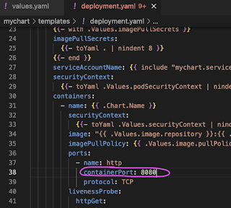](https://blogger.googleusercontent.com/img/b/R29vZ2xl/AVvXsEiSzCy-sNAoSC6IU2XC_HJTtsjIepM6HmSXE4i5sgyj8PMxzBDb-87yu-GEl5Y7dKaDXu1A_tcGA_unBCQAGYvs55eD2jIV5KEBPq-KfNfaDJBBDX928XFDn8V0ECM0aAhZ8YGeGZKnKlYb0ioP479Nbs_ua3kEEWBUIHEBH7G6fUn2DI5Xw0x4WSwF/s629/Screenshot%202023-04-30%20at%2012.06.47%20AM.png)

Save the files, commit and push into source code repo you are using.

**Make sure worker nodes are running**

kubectl get nodes

[](https://blogger.googleusercontent.com/img/b/R29vZ2xl/AVvXsEjPgmd_AhzwIX6ts6-zdbYkESuxLkxWC_2GMReNcJx7GXD6z4nghE4goAE8rs55ogO2IIU9tS8cBQRkSyKE6Ktif3nMGNDOFkSyXV82ejN4RqDOIU4sZGg5NhHaqeyY7FJ0-1-Yvv46ClqF80pmXNoW0wZUffy2Df6NaJq-jVoKgWl3TPLgT-76OoNE/s2004/Screenshot%202023-04-29%20at%203.19.08%20PM.png)

**Pipeline Implementation Steps:**

**Part 1**- Create Azure Build pipeline for building Docker image, uploading image into ACR and packaging helm chart.

**Part 2** - Create Azure Release pipeline for deploying Springboot Docker containers into AKS using helm upgrade task.

**Part 1 - How to create a Azure Build Pipeline**

1. Login into your Azure DevOps dashboard

2. Click on Pipelines.

[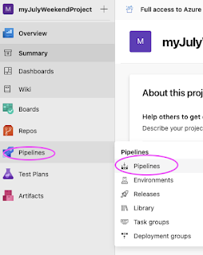](https://1.bp.blogspot.com/-JuBRkG2GXZw/YUN5x6idgHI/AAAAAAAADr8/d6fQG0gIXjsuCSlmAZvOVq2cnacaHBLAwCLcBGAsYHQ/s565/Screen%2BShot%2B2021-09-16%2Bat%2B12.05.02%2BPM.png)

3. Click on New Pipeline

[](https://1.bp.blogspot.com/-8lbBVkQk7LQ/YUN6N-vjJDI/AAAAAAAADsE/zqfb8m-JlCMJDYzgBQTN3L7Jsah9VcVmQCLcBGAsYHQ/s1609/Screen%2BShot%2B2021-09-16%2Bat%2B12.07.47%2BPM.png)

4. Click on use the classic editor

[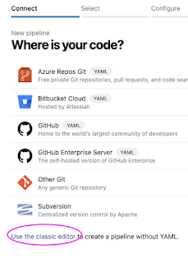](https://1.bp.blogspot.com/-fE1HvBb7I8Q/YUN6N7DHihI/AAAAAAAADsI/lvZpDSMLvpkEoNS5dwyAMxd3YJwQoOrNQCLcBGAsYHQ/s566/Screen%2BShot%2B2021-09-16%2Bat%2B12.07.56%2BPM.png)

Enter your repo name and branch name where you have stored your source code along with Dockerfile:

[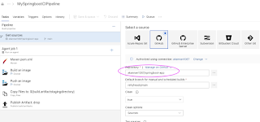](https://blogger.googleusercontent.com/img/b/R29vZ2xl/AVvXsEji9Xnr8MqByrjc5FCtjm0xajlLvbiU1YQyVX2eYqxlP9wqAd1R3fAhcUnV0QDKkjuqRBaFA5vXOEgXSHEmLIukYgIIZwr88A8Ig_kUXEUUoYd6mU3ZXVfbr7dAr3x75bfwwtYn7sdal9n_z5fYpZQIzoD7nW4s1IKGFF7xX6ltrWow2gdin6wlSZTA/s1352/Screen%20Shot%202022-06-29%20at%204.04.43%20PM.png)

Click on Continue. Now choose the template by typing Helm, Select Azure Kubernetes service and click Apply.

[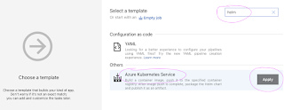](https://blogger.googleusercontent.com/img/b/R29vZ2xl/AVvXsEiMLHKTYZHo8iXmeC7MXQfBaYJyhgQNPvewDA_RsD5XWYSf-W7AgDJ-GOZM5msOkL-_YwdMKgpxFJhuKp0rKyTGj5egmfLX9T5iGiuqwA0y5mZzAcP_wDC2kvoieNN2HjMIqd2icTAwx1NYEslwIL3hLWryZy4IoVmd5PYinhqijmAbz8RRYIm3XSJV/s1063/Screenshot%202023-04-22%20at%209.53.43%20PM.png)

Now pipeline is created with six tasks already. We need to start customizing the pipeline:

Select Ubuntu as build agent from Agent specification drop down, avoid Windows server as build agent.

[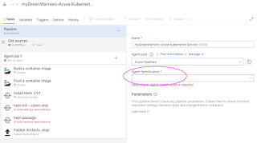](https://blogger.googleusercontent.com/img/b/R29vZ2xl/AVvXsEgqdPC3_vGS0ZX-9ni9BL5zlrZQjNuHhLOyfecsV_5oOLgyHLMA8WRCwGY1rOLVpaD_dr7uCgJl_v_pJmWFyTGXGuwRAFxRNqLB7ZV7nh6ZXpry1jxGanrTHJu12Qvm3nO9IqVWBvKh4psVLUxYguUYIpC2mGo0BvfNnyLdcDvzqBc5hVqpORkG6WCB/s1163/Screenshot%202023-04-22%20at%209.58.41%20PM.png)

[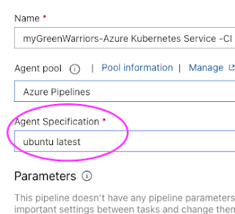](https://blogger.googleusercontent.com/img/b/R29vZ2xl/AVvXsEhEoHFQaunr3kMpL5KO-fg20rkl3QB9VMPFs9hIc50mt2ijascgFaZdIc73GhyQa77r6eFGOiTMpnYp-aS9SI5E7Exbln2N6ElSKA72AOwxX6dXSgmcr2kNhxMGVhanNBKx7mt68mXzcTkGhnDqD7uhSMYQ3Hzg7Ep4IZPiBU_ajNrpJA44FDn_-3ox/s347/Screenshot%202023-04-22%20at%209.59.30%20PM.png)

Let's also add Maven build task for building the JAR file.

Click on + icon and type Maven. this should be the first task.

And then enter maven goal as package

[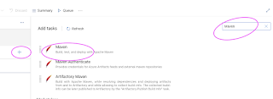](https://blogger.googleusercontent.com/img/b/R29vZ2xl/AVvXsEhVocJA4kZKgBp8sRGF8yLIGCvdJJ_iSOidWzYgc2TV5djVOXo3e0LeIcZcBhroD_8iWu2zC4m68kMGBz5bsYSmmoSO3Lc103gZcLsjpANa9Ufe300pxHdCJFyEiaZ8t0plnnKOR6Kaq3Y-XSv3M0poSEWntD9XBE4WGBXvo-7gi__o7FD9T-TDWzYD/s1131/Screen%20Shot%202022-06-30%20at%2011.09.37%20AM.png)

[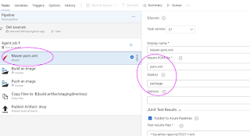](https://blogger.googleusercontent.com/img/b/R29vZ2xl/AVvXsEj5QiU3_VMzo1Rzf8djmb_D9kPzSRUDXMv1uJoUlLfOTY-VIMAu_tc1si0GCwkpZWbzR6-fxqOfy6ML4kyLx86r49DWxtfuGl4ah3uSOBdFFkz2dI2XLHBgZ2HOMCjHIdmONpXNIfXTcF8atSPhpCKLU7tTRwVFsXL_sNvxilUwmksubWHMQHfn3bUQ/s1102/Screen%20Shot%202022-06-30%20at%2011.08.16%20AM.png)

Let's modify Build an image task.

[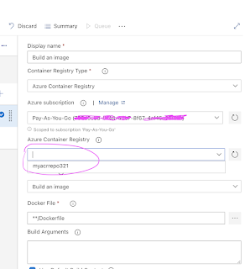](https://1.bp.blogspot.com/-NjobUV1kKEw/YVWnOFsuT-I/AAAAAAAADsw/9EnOD-D9JCAQrdcSkEOShCu0b6KdBwWJgCLcBGAsYHQ/s1386/Screen%2BShot%2B2021-09-30%2Bat%2B5.11.27%2BPM.png)

Select Push an image task

[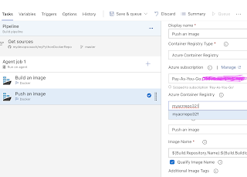](https://1.bp.blogspot.com/-4AfR6Y3cElM/YVWnoB8KM0I/AAAAAAAADs8/DVUmY67YIfM2C9iTV1PNiBqMSZAjYjwTACLcBGAsYHQ/s1722/Screen%2BShot%2B2021-09-30%2Bat%2B5.14.27%2BPM.png)

Leave Install Helm Task as it is, we need that task to install Helm on build agent

**Remove helm init task** by selecting remove selected task

[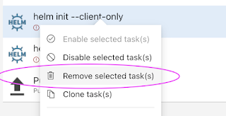](https://blogger.googleusercontent.com/img/b/R29vZ2xl/AVvXsEgyGzuyQQWRETJPRI-dpJaA00UGgBphdadbUq5ON3Trbr03zY5CBpk7gNMsVcsySNlDtINnWY8ZoFbjKiEAhl_GU7mB5bLXGs9cjMCx-4S5QbH3kHi3wesGqRdTbFb_wgaSVdAF7Y5iEAXzslkZnZH1xQ_09yqv5OMnUt1-P37DC5XG6nxo3mAYBkHe/s658/Screenshot%202023-04-28%20at%207.22.21%20PM.png)

Customize helm package task, select Chart Path by clicking ... dots

[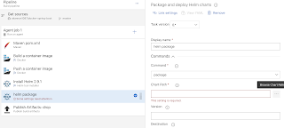](https://blogger.googleusercontent.com/img/b/R29vZ2xl/AVvXsEjzs1uizkaC_hbp9luUc8D0shhSnG6S0kRI8d721E_CEmsJqMBH1B6lLWGstmyRR8BolVGvX--483TUfcTN6Zi_ZLSf_eMdOzS2_bpJMJ-BBB35p1UIc4X4r6GHj-cW780C8BwxLaS0ASU_aYebyuXUXIgR5mZ8q7EYazU8cyFr-SCWrO8tohLoY_65/s2720/Screenshot%202023-04-28%20at%207.25.27%20PM.png)

Choose the folder where you have helm chart files, select OK

[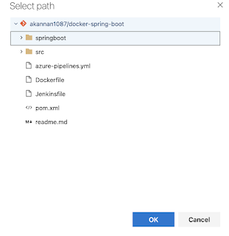](https://blogger.googleusercontent.com/img/b/R29vZ2xl/AVvXsEih9ht0TAhZkYwE9_4SFkpudE7J-deifReyam3IXqoD_v1dI3B3YcfLTWufUhizGr5-Gh4bwGztqSUXLUsLCps8LCsChsjIlxRxVGQobLxgwCU4_mfSnawOKP8p41OEwy4nOGoDUJqvynL0uaNTaL66R6AgVTwTTREV5N5uWmqElz5ZkMatTwJOxChM/s1112/Screenshot%202023-04-28%20at%207.25.35%20PM.png)

Leave Publish artifact task as it is.

[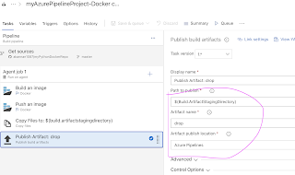](https://1.bp.blogspot.com/-pyl4UgTG8r0/YXrVx7KBDBI/AAAAAAAADuI/7eyhuLLvzrgYiE2cXJ-0X8d_NEBcaCKhACLcBGAsYHQ/s2032/Screen%2BShot%2B2021-10-28%2Bat%2B11.53.38%2BAM.png)

Now click Save + Queue and run to start Building the pipeline

[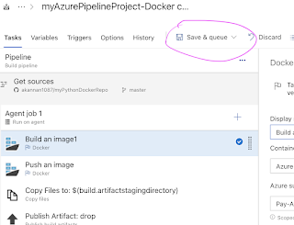](https://1.bp.blogspot.com/-E9GuDI5qGHQ/YXrWdLkE_UI/AAAAAAAADuQ/pU8rM5Zxc2E-I5EqaGrUATWAdklbPTqHgCLcBGAsYHQ/s1282/Screen%2BShot%2B2021-10-28%2Bat%2B11.56.25%2BAM.png)

Check build output..

[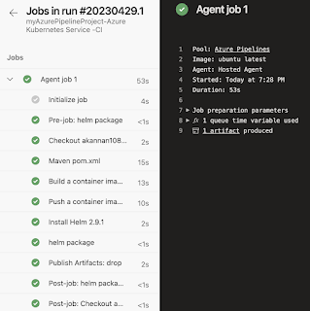](https://blogger.googleusercontent.com/img/b/R29vZ2xl/AVvXsEjYA195U6t4rmsxyoNqNp5rckLXggNXSka2T7Da-atgzbXiTHlwWujIuUmSUkW054AijvXS1kYftFXhDasYAQJYZJDC_6tSu-p_E7hNLLqkYpLCl1JdWss3l2zSb0gONYqaGoBDtqS2PCDCNKDr8Eqfo_aYPs9-LvA8IXvbQp1L07dvrzX2FqxHYk14/s1342/Screenshot%202023-04-28%20at%207.37.43%20PM.png)

Once the build is completed, you should be able to see the Docker image in Azure Portal under **Resource Group, ACR repo name --> Repositories**

[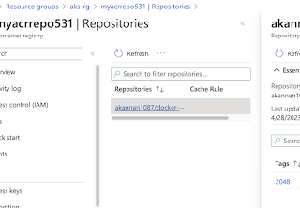](https://blogger.googleusercontent.com/img/b/R29vZ2xl/AVvXsEgrLkwm8ZX1YdTkg2mrTfDIBlR5pcQhcQdQv00VKV4qdI_zfHfRbGd-aGsf201jhz9VMB4Lxj5w3522MTCHbFV6E7atWXvv01QSsizgqbX7rkNl7JXYxHadweem7ejj9fh6MjUIyivDa-8Ch-PANHOTWqnD7h34wgbFDebmGYn2ZOf0TLuj47SxBDWF/s1472/Screenshot%202023-04-28%20at%207.40.11%20PM.png)

**Part 2  - How to Create Release pipeline for deploying Springboot Microservices containers into AKS Cluster**

**Go to Pipelines --> Click on Releases --> New Release pipeline**

**[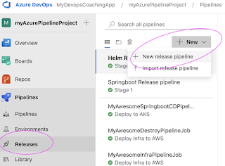](https://blogger.googleusercontent.com/img/b/R29vZ2xl/AVvXsEieKkaGUpWlXqtQePMbk7aIKrNStXDQnSxSbyWTj54kAozY4FdPuUgvd-I0DxQ4wCu3z-UL83APn2friTT7ahPuqrZS3k8lEwzvxP3a7euUxMq7v2KFKHfqUqpOe2B80DjERWx5kuqDtTquQQlZRNZzB7P7SQToHlNZMvAYzANEdkXyVfnpjzazAEeK/s1192/Screenshot%202023-04-29%20at%203.01.42%20PM.png)**

**Click on Stage 1 and choose a template by typing helm**

**and choose Deploy an application to K8S cluster using helm chart**

[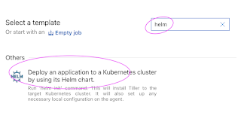](https://blogger.googleusercontent.com/img/b/R29vZ2xl/AVvXsEgoXYoomA-HokQfSZUZrUey4_6089TbD1WzHbcxyHYm4M4jAf6yscZ3GsyL4Dp26DN3bSYjPPdASNDhoLvvxOLyN-ahAwjS-0KWXO8syjBc93ODAvM-ZCPXZzv_oVdxuabMmpHfYh2vDZcU2YEgZuku6kXUZ87D3lgZ2hmp4k5xlyTTjKt2Hn-EpHdp/s1228/Screenshot%202023-04-29%20at%203.03.21%20PM.png)

**Change the stage name to Deploy to AKS**

[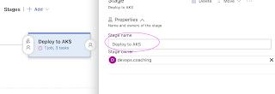](https://blogger.googleusercontent.com/img/b/R29vZ2xl/AVvXsEjK9Hiq2TQcORa7geJ2LWpqgDGsm5nKwuPPYk4y-xn2vRvHnbxGIz196G2Swojbzoi2H5v5yyV0xBlAsv6RPzhZqh9HubR6m8tMZ62I7STXF7d4iZn-8KJs_1oyAJouWFvJaVRylVTccyOEIKYYthTAZirD3J-9QfjIerNkF5VG7KlZIbt-N5hElwbo/s1770/Screenshot%202023-04-29%20at%203.06.29%20PM.png)

**Now click on Add an artifact**

**[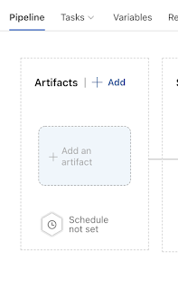](https://1.bp.blogspot.com/-dxc2Ol4lcpY/YXrsO6C9IaI/AAAAAAAADu8/UVGLRsTCSXAFBMt8MWaZX6ts7o95aSXxgCLcBGAsYHQ/s874/Screen%2BShot%2B2021-10-28%2Bat%2B1.22.03%2BPM.png)**

**Select the Build pipeline and click on the latest version**

[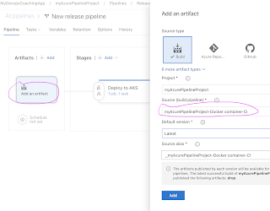](https://1.bp.blogspot.com/-iQMVFgXHYoM/YXrsFN1DaDI/AAAAAAAADu0/Q0AH0rqVTXoCyzBitTjI92LEj41PDbi0gCLcBGAsYHQ/s1874/Screen%2BShot%2B2021-10-28%2Bat%2B1.22.33%2BPM.png)

Now click on Deploy to AKS stage

Click on Deploy to AKS

[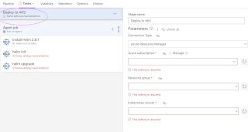](https://blogger.googleusercontent.com/img/b/R29vZ2xl/AVvXsEgTy11kitlOnYuVBq3g40teHcu1Ao_piZYWZTslI8kb3GAOwyJSC9QecogaUNOLTA5Jm0cpFnm3zES8SzJG-DyBupx97z8bZ77I0dYhb4hLgdy8UFnivbjxDCB_9TOzU4bwXSi9OHDFeW23WIGo90_dDhrjQt_k-l9dvLUMFDhOZ6GVc2jE0GXocFv8/s2292/Screenshot%202023-04-29%20at%203.08.03%20PM.png)

Enter right value for Azure subscription, Resource group and AKS Cluster by selecting from down down.

[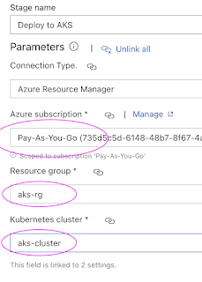](https://blogger.googleusercontent.com/img/b/R29vZ2xl/AVvXsEjlkxBIfsWVbXNXaTj3HzxVmnwvJQMszlaHjBU9BpWIXY_blvQDmYDeroLM5KKv3okn37SYw6tRuZ9oDRUjUfpSn9IRpBh0p2N6bUmVLNraSjLIPfvn852b5_muIr-hnJs1FQY-Ff5rSJ_0DsddG09frroM2tSp76xuE8CYsmC8uS9SjBmbKQk1LjN4/s950/Screenshot%202023-04-29%20at%203.08.48%20PM.png)

Now click on the Agent Job, and select Azure pipelines and choose Ubutu as Build agent, avoid windows agents.

[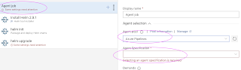](https://blogger.googleusercontent.com/img/b/R29vZ2xl/AVvXsEiz7duF-f7WuTlI5Ctjqpky2_qL74tn8Kg2b_27VycgWem6EWi8tj1APZ7SAYTO4JaCLg6_r92L8sCWGReoJ9TK762-R18ZN2X3oaplgd658J2_TurGCdOpYTFBKfaiKwquLLpGrlAm5DKZII7kZy4J55m20eSXidnFojhTzyTh-jt2-20fx9ozZ708/s2294/Screenshot%202023-04-29%20at%203.13.39%20PM.png)

Leave install Helm 2.9.1 task

make sure check for latest version of Helm. this will install latest version of Helm which is 3.x

[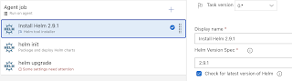](https://blogger.googleusercontent.com/img/b/R29vZ2xl/AVvXsEjUPBFHijZTqWm-KI0n0wnHdB4FifqQlpHRcv2RwtXbSs2jeJ4zqw2Ws-W8jv72ZM6DZcszquwsihfnxOINbBfAWnGzXkkJkPIn3V00SXSaXJlgb1dWupw7cV3vsZnIpvhunuV8EwR4TNes2-Mo7q3mq-VSrN-Kcxt-1rAj36yHTPI5EnsLxzVcjJPb/s1770/Screenshot%202023-04-29%20at%203.21.52%20PM.png)

**Remove helm init task** by selecting remove selected task

[](https://blogger.googleusercontent.com/img/b/R29vZ2xl/AVvXsEgyGzuyQQWRETJPRI-dpJaA00UGgBphdadbUq5ON3Trbr03zY5CBpk7gNMsVcsySNlDtINnWY8ZoFbjKiEAhl_GU7mB5bLXGs9cjMCx-4S5QbH3kHi3wesGqRdTbFb_wgaSVdAF7Y5iEAXzslkZnZH1xQ_09yqv5OMnUt1-P37DC5XG6nxo3mAYBkHe/s658/Screenshot%202023-04-28%20at%207.22.21%20PM.png)

Let's start customizing helm upgrade task. Enter **helm-deployment** as namespace, chart type as File path and click on three dots.

[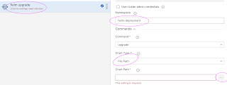](https://blogger.googleusercontent.com/img/b/R29vZ2xl/AVvXsEiH_iLlSnUxehz8NW8TUSGt1R-TYAH9qSIX1R2ZxjkqDUSyiOrGUKKQj44Pm8r5uX9clWkKMfBw8q7gqnYgjNkJNjkiMV_i3Nx9KWjnxIURVo-hxr7PEDliZFIBE_THtTCoXzOjnfZYmhDLEK2vRmTXedG9XyV894m5mMfWDKWrf0wjIZo8pLoVXXHk/s2308/Screenshot%202023-04-29%20at%203.27.40%20PM.png)

choose the package mychart-0.1.0.tgz and click ok.

[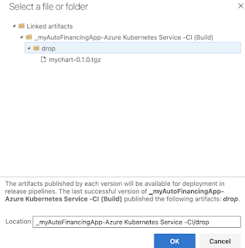](https://blogger.googleusercontent.com/img/b/R29vZ2xl/AVvXsEjfG83HESiUTLMuPKXF_A0DZM5ibjlmlBNHQjLhU7LVzRoq1b7XzY2VpkLPCoNuZrdO16xGsg-8H5E2fKNbwemSV0luIkpguFt0RgFHCwQ5SRjOAa8S77-RgGKv9Gt1_5YY3Lq5GMHn-LeRWZUYq6ufpLowx9ouBYqJFDUMJGxPhMUQJ-dROgPUeOBS/s1070/Screenshot%202023-05-03%20at%204.22.50%20PM.png)

Enter **first** as release name

enter below values for for set values:

**image.tag=$(Build.BuildId)**

[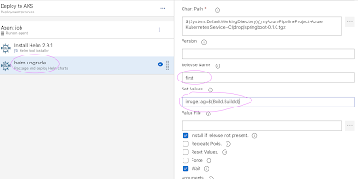](https://blogger.googleusercontent.com/img/b/R29vZ2xl/AVvXsEi-9sLDeZQaVd_oF1whkqovYw1ctiGFZg1tuPPW1rCTUP-16vah_bKLLct_Y5WQXB_5jmabq-YZ2P-Yao87ebq3oRQ_KPX-EW39L-I8dVhWFCiZzvfrit_0T_2rOkBkjJCFVzGFjiVFrs48xc5dUQbC__pEwHJRKl_aJ72ETTCrplVT88eEH3d4M2cU/s2286/Screenshot%202023-04-29%20at%203.34.19%20PM.png)

Now click on Save.

**Optional step - Enable Continuous Deploy Trigger**

This will deploy microservices into AKS cluster for every new build in build pipeline.

[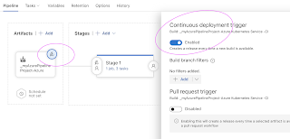](https://blogger.googleusercontent.com/img/b/R29vZ2xl/AVvXsEgHfrpjRqC4zSpJpoAn2y28_Idm3WulLvTNJXkmixvW6P0N4hvzTyxf2JetFVz5bA3COIMKTWUXhfxqts-D0FqjjKylLl5mnTPTvaDwBYhHz81OfPPcN-W59EO1eJjUPuBiigrXpilVrKliVgxFHy6NLFEx0eVFrGdClaG8EhqyrIxQAAzuXnT3t1XJ/s2044/Screenshot%202023-04-29%20at%204.12.31%20PM.png)

Click on Create a release

[](https://1.bp.blogspot.com/--Y-NT_aZ2eY/YXr7tpaxQqI/AAAAAAAADwg/-9AMUvTgqo8mGQBlvmxoCn_m9hEzaYmBgCLcBGAsYHQ/s1380/Screen%2BShot%2B2021-10-28%2Bat%2B2.35.42%2BPM.png)

and then click Create

[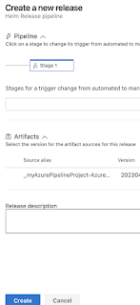](https://blogger.googleusercontent.com/img/b/R29vZ2xl/AVvXsEjbmfY6VtNFl6XmQmbchr-upj6n_dzBLBAo2CkJO9-tDKLP38aJAMtmGxDihBEKMwoOekbPDz_VxYURO_IgCaZd37S4xuvYa53Z_eQ2vWNwGRbZQRby1MEE8o4CaPt3CJ1VdFPpIK2eet-nQq878KwElka763Lis69fh4yyxbVC74tRKmsJ-jL4wTAu/s1508/Screenshot%202023-04-29%20at%204.16.42%20PM.png)

Click on Release number to see the output

[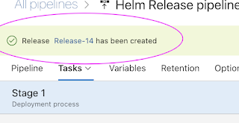](https://blogger.googleusercontent.com/img/b/R29vZ2xl/AVvXsEjx8HEfAi-7xTrxAK9Xn0vNul0JciojisvJHYQBca0uE5KHvco6kCpa6yXMt7IL1avhIfBda4eqq1nTWAvSt0TIozqw4KUrErqaFSZUu6qMJaBcJC8xvdrk3NO_gJog8JkKJd1fAlSI6ywPWunczmtOtY5nZWbRv4kY6rhBtVI-VLM9OfGd2E5ahUND/s764/Screenshot%202023-04-29%20at%204.18.12%20PM.png)

Click on Stage to see the logs

[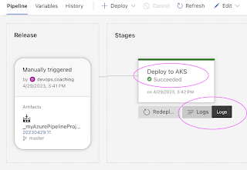](https://blogger.googleusercontent.com/img/b/R29vZ2xl/AVvXsEibyUxBWQDMEpI0JaX9im9kULO8SedZuSPtsptQ5m_vLJg7k4UNVmr3wmgqaqtNhDuGw7ZAIDDDwNXJfQEBfbClEEmZVO_Xc0vJ-TMShBGUyoNtUXbC-alv7Lr2h5nt1Ctb-qrSi2vUsDr5fWUN5CDb60OhbZ9UBSnzBrea614pBu52ZOAVBwLSWcoQ/s1286/Screenshot%202023-04-29%20at%203.43.13%20PM.png)

Click on Logs, you will see the following tasks are in green to confirm Deployment was successful.

[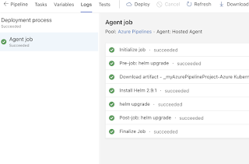](https://blogger.googleusercontent.com/img/b/R29vZ2xl/AVvXsEjoJtq4q8kXi_-LEqsP12yA9VhDiWHXhdqB3ulijiuPzV5KWdfzNJOhlJpzGpiODZVoTc3FArVmSgSfkv3x1pZZ0SB1-NNj9IDo3VGPFD-rjZAsaCrKFQEe4KpkIxMysbg0E1IUPObWz0lufnS8WtOdiyE7v3_anh_D_y4JmloGzZGy32RbFqLsIzfA/s1462/Screenshot%202023-04-29%20at%203.43.45%20PM.png)

Let's check if deployment created any pods in helm-deployment namespace.

**How to access Springboot Application using port forward locally?**

kubectl get deployments -n helm-deployment

[](https://blogger.googleusercontent.com/img/b/R29vZ2xl/AVvXsEjvZHh5snjFCQ8Csal3Y0Ujlo2F1bZVzwtUU_h9auaKE9YXAeA7UDHJB7Eyqh224yntCGzU_HL4kxqP-z4JCJWtFhJPj5FOYUhERdy_fgjQbcoPMpjmzMZq9c31Wxr7skvR86c0HA-IBPRnPeBh5m1RPLnLYVGnDMWQQThuHRaBAh2GIuxL60BPrBYU/s2540/Screenshot%202023-04-29%20at%203.45.47%20PM.png)

kubectl get pods -n helm-deployment

[](https://blogger.googleusercontent.com/img/b/R29vZ2xl/AVvXsEgMhRb4H9oOSl4S84OZDNshnTQzykxBVJDiSzrxmGPiVvqQbkXE-4hzZaBc8f9ZDkIqjaLaZHFWL6EC9z8cDn3DCxlI61lYhFBY58tFMRX5WsSF8MCbYCb7ePfiWUHC_qLOhJ00lnHhKDox8JlwWAwQSEIuqMhKPMFIQ4QyjYpce5Vwailp3XugcN1H/s2388/Screenshot%202023-04-29%20at%203.45.57%20PM.png)

**Get the pod name and use port forward to access locally**

kubectl port-forward first-springboot-pod_name 8080 -n helm-deployment

[](https://blogger.googleusercontent.com/img/b/R29vZ2xl/AVvXsEgDp8zZ88dB6rcvWZazsggZrV4UeKCCj2x_7AYIJJSP1xtPS8iLByHN-gJYV2gJ1Aen9ZohrAPAUzekRNenNWkM0Z4IJ8goGxnc2z2JqNEZLuMpYRaooRDAT9jHsPH_OQ3ik5Q69hj-r6L3DNZLCB1C_md6k9hEXiHFcC8wRIJByO8YAVoW75ZjyRrR/s2700/Screenshot%202023-04-29%20at%203.48.51%20PM.png)

If you see any errors after deploying the pods, you can check the pod logs.

kubectl describe pod <pod_name>  -n helm-deployment

Go to the browser enter http://localhost:8080

You should see below web page.

[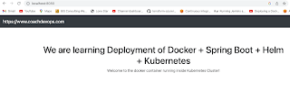](https://blogger.googleusercontent.com/img/b/R29vZ2xl/AVvXsEibmm-SOE5DQVd_JRTIJxXJbzRudgdMM6QXdcXjIrrnDotccyvDlH53ODr9a2nDIXWLdqn4qhX_3zOB-VCIQ_CA8jajSu3UZOkkQmWJ0MhW8LqxkmPou2V-ZRamQD21fAdgrQaJvGS5UPIy0P3N30yO5cyl99qPV7Uzcx5dbnQBLsyWchNRpCmYD3Uh/s2544/Screenshot%202023-04-29%20at%202.13.05%20PM.png)

**Clean up Resources**

Let us see how to clean up the resources that were created. We can use [az group delete](https://docs.microsoft.com/en-us/cli/azure/group" \l "az-group-delete) command to remove the resource group, AKS cluster, and all related resources.

az group delete --name aks-rg --yes --no-wait